The following questions are based on the accompanying documents (1-5). It is designed to test your ability to examine and interpret the meaning of the documents.

**Effects of Spanish Colonization on Native American Tribes of Florida**

**Grade 4**

**Historical Background:**

In 1492, Christopher Columbus sailed across the Atlantic Ocean from Europe and landed in the Americas. In 1565, St. Augustine, Florida was established by the Spanish and is the oldest permanent European settlement in the United States. Spanish Colonization greatly impacted the Native American Tribes of Florida.

**Task:**

Read each document carefully and answer the question or questions after each document.

**Directions:**

* Read the task. Do you understand it?
* Ask yourself: “What do I already know about the Spanish arrival, exploration, and colonization of Florida? How would I answer the question, even if I could not look at the documents?”
* Now look at the documents. Study each one and highlight any information that will help you answer the question. Ask yourself: “How does this help me to answer the question?”
* Each document is followed by a question(s). Write an answer to each of these questions in the blank that follows it.

**Document 1:**

St. Augustine, Florida was established by the Spanish in 1565 and is the oldest permanent European settlement in the United States.

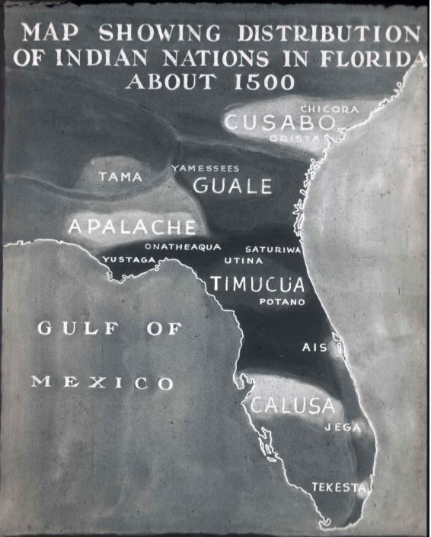  
 *Source: National Park Service*

1. Based on the document, what year does the map represent?

*___________________________________________________________________*

1. According to the document, who was living in North Florida?

*___________________________________________________________________*

1. Were Native Americans or Spaniards living in Florida first?   
   *___________________________________________________________________*

**Document 2:**

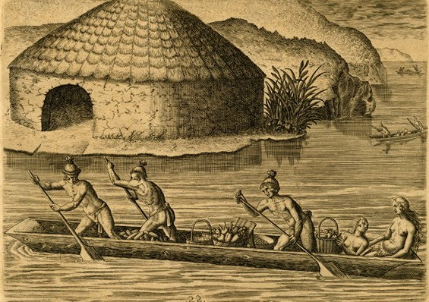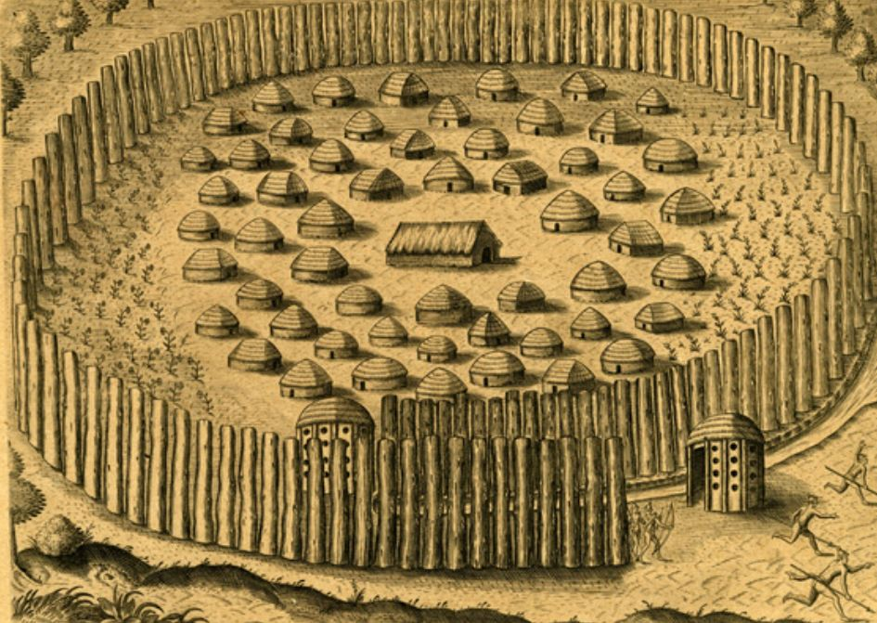The images below illustrate how the Timucua may have lived and traveled. They were created around 1591 by Theodore de Bry, from Belgium, and are possibly based on drawings by Jacques Le Moyne, who left France to explore Florida.

*Source: Florida Memory (adapted)*

1. Based on the documents’ authors, are these images from a European or Native American point of view?

*______________________________________________________________________________________________________________________________________*

1. Based on the documents, describe one aspect of the Timucua culture.

*______________________________________________________________________________________________________________________________________*

*___________________________________________________________________*

**Document 3:**

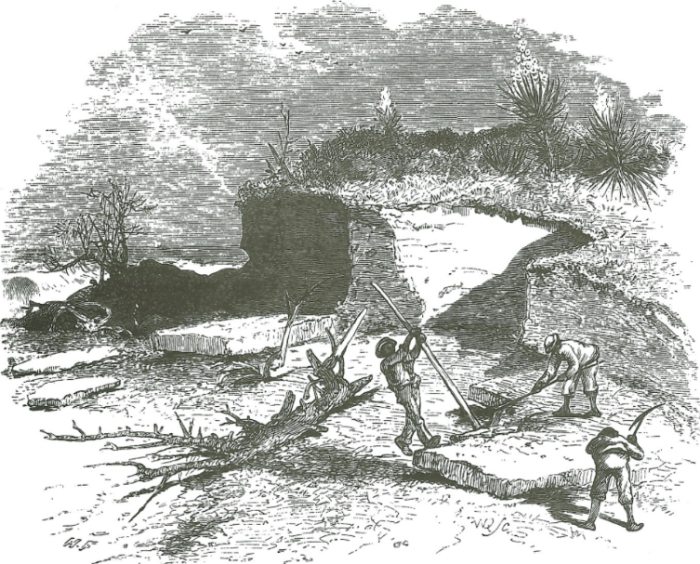The Timucua, Guale, and Apalache made up the largest group of laborers to construct Castillo de San Marcos. Franciscan Friar Alonso del Moral accused Spanish authorities of forcing Native Americans to work *“without paying them that which is just for such intolerable work.”* They were forced to work in the coquina quarry and collect oyster shells which led to painful cuts that often became infected.

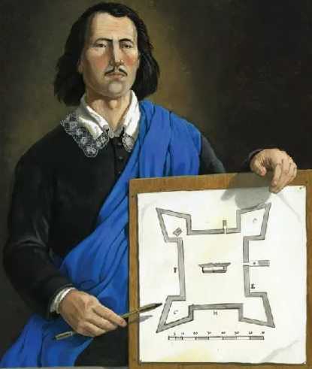

Source: National Park Service (adapted)

1. Based on these documents, who built the fort?

*______________________________________________________________________________________________________________________________________**____________________________________________________________________________*

1. Based on these documents, describe one hardship Native Americans faced.

*__________________________________________________________________________________________________________________________________________________________________________________________________________________*

**Document 4:**

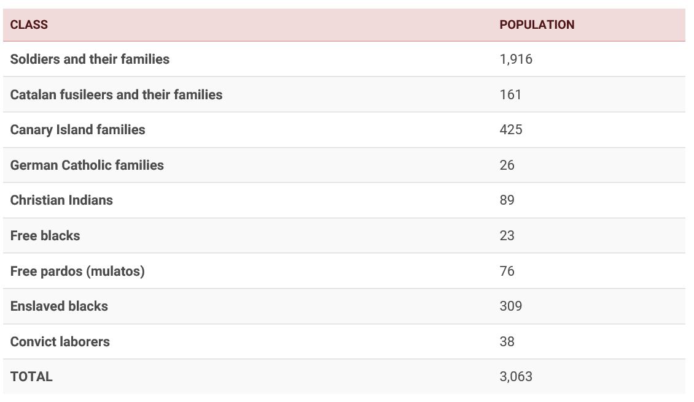There were hundreds of thousands of Timucua, Guale, and Apalache before the Spanish arrived. Most died from diseases brought by the Europeans. Those who survived disease and war did so mostly by intermarrying with the Spanish or by joining other tribes, like the Yamasee and Creek.   
  
 **St. Augustine’s Population in 1763**

Source: Florida Museum of Natural History, University of Florida (adapted)

1. Based on the document, what was the population in 1763 of “Christian Indians,” also known as Native Americans?

*___________________________________________________________________*

1. Based on the document, what effects did the Spanish colonization have on the Native Americans? Justify your answer using the information above.

*_________________________________________________________________________________________________________________________________________________________________________________________________________*

**Document 5:**

This map of St. Augustine from around 1783 illustrates forts and villages.

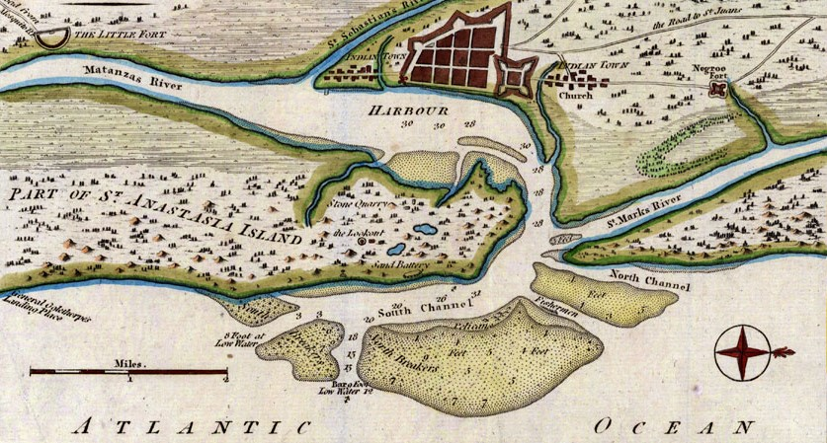*Source: University of South Florida (adapted)*

1. Based on the document, what year was this map drawn?

__*____________________________________________________________________*

1. Based on the document, describe what was built after the Spanish arrived.

*____________________________________________________________________________________________________________________________________________*

*____________________________________________________________________________________________________________________________________________*